

L.K.I.Silva

AS2020978

K.D.Y.Niwarthana

AS2020979

ICT 334 2.0 Final Year Project

Project Report

Online Book Buying Exchanging System

Year 03, Semester 02

2024

# Abstract

This report delves into the functionalities of Literary Loop, an online platform tailored to meet the evolving preferences of book enthusiasts in a digital-centric world. At its core, Literary Loop fosters a renewed appreciation for physical books through its diverse range of features. The membership system, meticulously curated and administered by diligent administrators, ensures a secure and dynamic community. Central to Literary Loop's foundation is its versatile book exchange and buying system, accommodating various user personas with tailored access and privileges. Administrators play a pivotal role in managing book listings, and facilitating seamless exchanges within the platform. Additionally, Literary Loop empowers users with a user-friendly book-selling system, streamlining transactions for effortless book sales. While the platform currently prioritizes delivering a seamless user experience through its registration and login functionalities, its commitment to simplicity is further emphasized. Overall, Literary Loop emerges as a transformative platform, bridging the divide between digital and tangible literature with finesse and efficacy.

# Contents

Abstract

Contents

Chapter 1 - Introduction

1. Introduction
2. Objectives
3. Project Scope
4. Limitations
5. Documents Arrangement

Chapter 2 – Requirements analysis and specification

1. Introduction
2. Drawbacks of the current systems
3. Advantages of the Literary Loop system
4. Functional Requirements
5. Nonfunctional requirements
6. Requirements analysis
7. Use case diagram

Chapter 3 – System Designing

1. Selection of the process model
2. Tools used for designing
3. Activity diagram for exchanging a book
4. Sequence diagram
5. Database design
6. User Interface design

Chapter 4 – System Development

1. Hardware configuration
2. Software configuration
3. User Interface development

Chapter 5 – System implementation & Maintenance

Chapter 6 – System Testing & Evolution

Discussion

Future Enhancements

Group Members

**Chapter 1**

# Introduction

This report presents an in-depth exploration of the multifaceted functionalities integrated into Literary Loop, an innovative online platform tailored to the evolving needs of bibliophiles. In response to the digital era's dominance, Literary Loop emerges as a beacon, fostering a renewed appreciation for tangible literature through its comprehensive suite of features.

At the heart of Literary Loop lies its membership system, carefully curated and administered by diligent administrators. Membership approval hinges on admin review, ensuring a secure and dynamic community of book enthusiasts. This foundational aspect underscores the platform's commitment to fostering meaningful connections among users.

Central to Literary Loop is its versatile book exchange and buying system, catering to diverse user personas. Unregistered users gain basic access, while registered users unlock the ability to purchase books. Members, after approval, enjoy the unique privilege of exchanging books, facilitated by seamless admin oversight.

The dynamic interaction between users and administrators is highlighted in the book management functionality. Administrators meticulously curate and maintain an exchange book list, facilitating seamless book requests and exchanges for members. The pivotal role of administrators in managing book listings, including additions, deletions, and updates, ensures a smooth and responsive ecosystem for book transactions.

Furthermore, Literary Loop boasts a user-friendly book-selling system, empowering customers to effortlessly sell their used books. From entering book details to uploading photos and completing transactions, users navigate a streamlined process facilitated by secure payment integration.

The platform's dedication to user satisfaction is evident through its customer-centric approach, notably its contact us page, which enables users to submit messages. This streamlined communication channel ensures that users can easily reach out with inquiries or feedback, fostering a transparent and interactive support ecosystem.

Registration and login functionalities round out the user experience, providing seamless access to Literary Loop's wealth of features. By effortlessly creating accounts and securely logging in, users unlock the platform's full potential, enabling them to explore, engage, and connect within the vibrant Literary Loop community.

In summation, this report illuminates the transformative journey of Literary Loop, from its inception as a visionary concept to its realization as a dynamic and inclusive platform for bibliophiles worldwide. Through its array of functionalities and unwavering commitment to user satisfaction, Literary Loop redefines the digital literary landscape, bridging the gap between virtual and tangible literature with unparalleled finesse and efficacy.

# 1.b)Objectives

* Provide a platform where users can economically exchange physical books, promoting a cost-effective alternative to traditional book purchasing.
* Create a space that enables members to access rare and hard-to-find books from the personal libraries of fellow enthusiasts, broadening the scope of their reading experience.
* Offer a user-centric marketplace for the selling and buying of pre-owned physical books, allowing individuals to sell their books at a comfortable price and encouraging a sustainable cycle of book circulation.
* Enhance the book exchange experience by enabling users to contribute their books to the platform in return for requesting a specific book available in the system, ensuring a secure and reciprocal exchange.
* Create opportunities for students and educators to access a wide range of books for academic purposes, reducing financial barriers.
* Implement robust security measures to protect user data and privacy, ensuring a safe and trustworthy platform.
* Provide additional resources such as book reviews and author information to enhance the overall reading experience.
* Implement a Contact us platform to enable users to engage in interactive sessions with the system's administrator.

# 1.c)Project Scope

The scope of the Book Exchanging System encompasses the development of a comprehensive online platform designed to facilitate the exchange, buying, and selling of books in a secure and user-friendly environment. The system caters to three main user types: unregistered users, registered users, and members, each with distinct privileges and functionalities.

Admin oversight ensures the smooth operation of the platform, with features including membership approval. Admins curate and maintain the book inventory, facilitating exchanges and ensuring a diverse selection of titles available for users.

Members gain exclusive access to book exchange privileges, subject to admin approval, fostering a dynamic community of book enthusiasts. The platform integrates seamlessly with a payment system to facilitate secure transactions for book sales.

Additionally, user inquiries are managed through a Contact Us page, ensuring users have access to accurate and updated information.

Effortless user registration and secure login functionalities provide users with access to explore and utilize platform features, enhancing the overall user experience.

Through these features, the Book Exchanging System aims to provide a reliable and efficient platform for book enthusiasts to engage in book transactions, fostering a vibrant and interactive community of readers and sellers.

The specific users for this Literary Loop are,

* Unregistered user
* Registered User
* Members
* Administrator

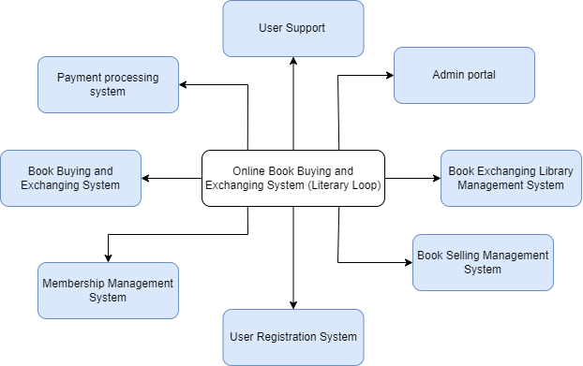The modules that are included in this Literary Loop website, are shown using a context diagram. It indicates the main modules of the system.

# Limitations

Not all customers may be proficient in using technology or feel comfortable navigating online platforms. Some users may prefer traditional methods of purchasing books, such as visiting physical bookstores, due to a lack of familiarity with online systems. Overcoming this limitation requires implementing user-friendly interfaces and providing clear instructions to enhance the accessibility of the platform.

The online book exchanging and buying system may require additional resources to provide technical support to customers who require assistance with using the platform. Addressing user inquiries and troubleshooting technical issues effectively may pose challenges, especially for users with limited technological proficiency. Ensuring prompt and efficient customer support services is essential to overcome this limitation.

Some customers may have reservations about the security of transactions and the protection of their personal information. Building trust and ensuring the security of user data on the platform is crucial to overcoming this limitation.

The selection of books available for exchange or purchase on the platform may be limited, particularly for niche or less popular titles. Providing a diverse and comprehensive range of books may require extensive partnerships with publishers and suppliers, which could be challenging to establish and maintain.

# Document Arrangements

**Requirement Analysis & Specification**

This chapter discusses the current system and examines the aspects of the proposed system. It also includes a detailed account of various operations performed to gather and analyze the requirements. Case diagrams were used to specify the features of the proposed system.

Our system offers a streamlined user registration process, making it easy for individuals to create accounts and securely log in, fostering increased user participation and engagement with the platform.

**System Designing**

The entire system is designed using appropriate UML diagrams based on the identified requirements. This chapter gives a detailed account of the design of the databases, interfaces, and modules of the system.

**System Development**

This chapter discusses the conversion of the system into computer-understandable language. The new system has been constructed into functioning modules within this phase.

**System Testing & Evaluation**

This chapter is engaged with testing each deliverable from the development to determine whether the system is working properly.

**System Implementation & Maintenance**

This chapter concludes how the installation process was carried out in replacing the current system with the new system. It includes how the conversion of existing data, software, and documentation were done.

**Discussion**

This includes the overall discussion of the system developed.

**Chapter 2**

# Requirement Analysis & Specification

# Introduction

This chapter provides a concise overview of the requirement specification process and an analysis of the current management processes along with their associated drawbacks. The requirement specification process entails identifying both functional and non-functional requirements through various requirement-gathering techniques. Functional requirements are elucidated using use-case diagrams to provide a comprehensive understanding of the system's functionalities. Additionally, this chapter outlines the existing challenges within the current processes and proposes techniques incorporated into the new system to address these issues effectively. The proposed system serves as a solution to overcome the limitations encountered in the current management processes, aiming to enhance efficiency and streamline operations for optimal performance.

# Drawbacks of the current book exchanging processors

**Limited Access**

Manual processes restrict access to a limited pool of books, often confined to local availability and physical bookstores.

**Time-Consuming**

Finding desired books through manual searches can be time-consuming and inefficient, requiring extensive browsing and inquiries.

**Lack of Diversity**

Manual exchanges may offer limited options, especially for rare or niche books, hindering users' ability to access diverse titles.

**Higher Costs**

Manual transactions often involve additional costs such as travel expenses and inflated prices due to limited availability.

**Security Risks**

Manual exchanges pose security risks such as potential fraud and lack of accountability, leading to concerns regarding the safety of transactions.

**Advantages of Literary Loop System**

**Comprehensive User Authentication and Authorization**

Our system provides robust user authentication mechanisms, ensuring secure access for different user types and offering additional functionalities for registered users and administrators.

**Zero Loss Exchange**

Members are accepted upon submitting a book to the admin, ensuring a fair exchange where both parties receive a book, eliminating any potential loss in the process.

**Efficient Book Management**

Administrators benefit from dedicated tools for book management, allowing for seamless addition, deletion, and updating of book information, enhancing the overall organization and accuracy of book listings.

**Integrated Book Exchange**

Our system integrates book selling, buying, and exchange functionalities seamlessly, providing users with a cohesive and convenient platform for all their book-related transactions.

**Enhanced User Support**

Through features such as the "Contact Us" functionality, our system prioritizes user support, enabling users to easily submit inquiries and receive timely assistance from administrators, improving overall user satisfaction.

**User-Friendly Registration Process**

# Functional Requirements

**User Authentication and Authorization**

The system shall provide user authentication mechanisms to ensure secure access for different user types, including administrators, registered users, and unregistered users. Registered users and administrators shall have access to additional functionalities compared to unregistered users.

**Membership Approval**

The system shall include functionality for administrators to review and approve membership requests from users interested in becoming members of the book exchange community. Upon approval, members shall gain access to exclusive features such as book exchange privileges.

**Book Management**

Administrators shall have the ability to manage books within the system, including adding, deleting, and updating book information. The system shall maintain an exchange book list for members to browse and request books for exchange.

**Book Selling**

Users shall be able to list their used books for sale on the platform by providing book details and uploading photos. Upon successful submission, listed books shall be added to the system and displayed for sale to other users.

**Book Buying**

The system shall enable users to browse a list of available books for sale, select desired books, and proceed with the purchase. Users shall have the option to contact the seller for additional details before finalizing the purchase transaction.

**Book Exchange**

Members shall have the capability to initiate book exchange requests by selecting a book from the exchange list and submitting details of their book for exchange. Administrators shall review and approve book exchange requests, facilitating the exchange process between members.

**Payment Integration**

The system shall integrate secure transactions for book purchases and payments for listed books.

**User Support**

The system shall provide user support functionalities, including a "Contact Us" feature for users to submit inquiries and receive assistance from administrators.

**User Registration and Login**

The system shall offer user registration functionality for individuals to create accounts by providing the necessary details. Registered users shall be able to securely log in using their credentials to access the system's features and functionalities.

# Non-Functional Requirements

**Usability**

The system shall feature a clean and intuitive user interface, ensuring ease of navigation and use for both customers and administrators. User interactions within the system shall be straightforward and intuitive, minimizing the need for extensive training or guidance.

**Security**

The system shall prioritize security measures to safeguard the confidentiality and integrity of user data, including customer and administrator information. Authentication and authorization mechanisms shall be implemented to control access to sensitive system functionalities and data. All data transmitted and stored within the system shall be encrypted to prevent unauthorized access or interception.

**Compatibility**

The system should be compatible with a variety of devices, operating systems, and web browsers to ensure that it can be accessed by a wide range of users.

**Maintainability**

The system shall be designed with modularity and scalability in mind, allowing for easy maintenance and updates to accommodate evolving business requirements and technological advancements. Codebase documentation and version control practices shall be maintained to facilitate efficient system maintenance and future enhancements.

**Performance**

The system shall be capable of handling concurrent user interactions and high volumes of traffic without experiencing significant degradation in performance. Response times for key system functionalities, such as browsing books, adding items to the cart, and processing payments, shall meet predefined performance benchmarks even under peak usage scenarios. The system architecture shall be scalable to support future growth and expansion, ensuring consistent performance as user demand increases over time.

# Requirements Analysis

**Actor Glossary**

|  |  |  |
| --- | --- | --- |
| Actor | Synonyms | Descriptions |
| Administrator | admin | Plays a central role in managing the book exchange platform. Their responsibilities include approving memberships, managing books within the system, overseeing book exchanges, and ensuring the overall functionality and security of the platform. Administrators have the authority to review and grant permissions for membership requests, curate and maintain the exchange book list, and handle customer inquiries. |
| Unregistered User | Guest user | An unregistered user refers to an individual who accesses the book exchange platform without creating an account or logging in. Unregistered users have basic access to the platform's features and functionalities, such as browsing available books for sale and viewing general information. However, they may not have access to certain privileges reserved for registered users and members, such as purchasing books or participating in book exchanges. |
| Registered User | Account holder | A registered user is an individual who has created an account on the book exchange platform by providing the necessary details and completing the registration process. Registered users have access to additional features and functionalities compared to unregistered users. They can browse, purchase, and sell books on the platform. |
| Member | Subscriber | A member refers to a registered user who has been approved by the administrator to join the book exchange community upon sending a book to the system. (Administrator) |

# Use Case Diagram

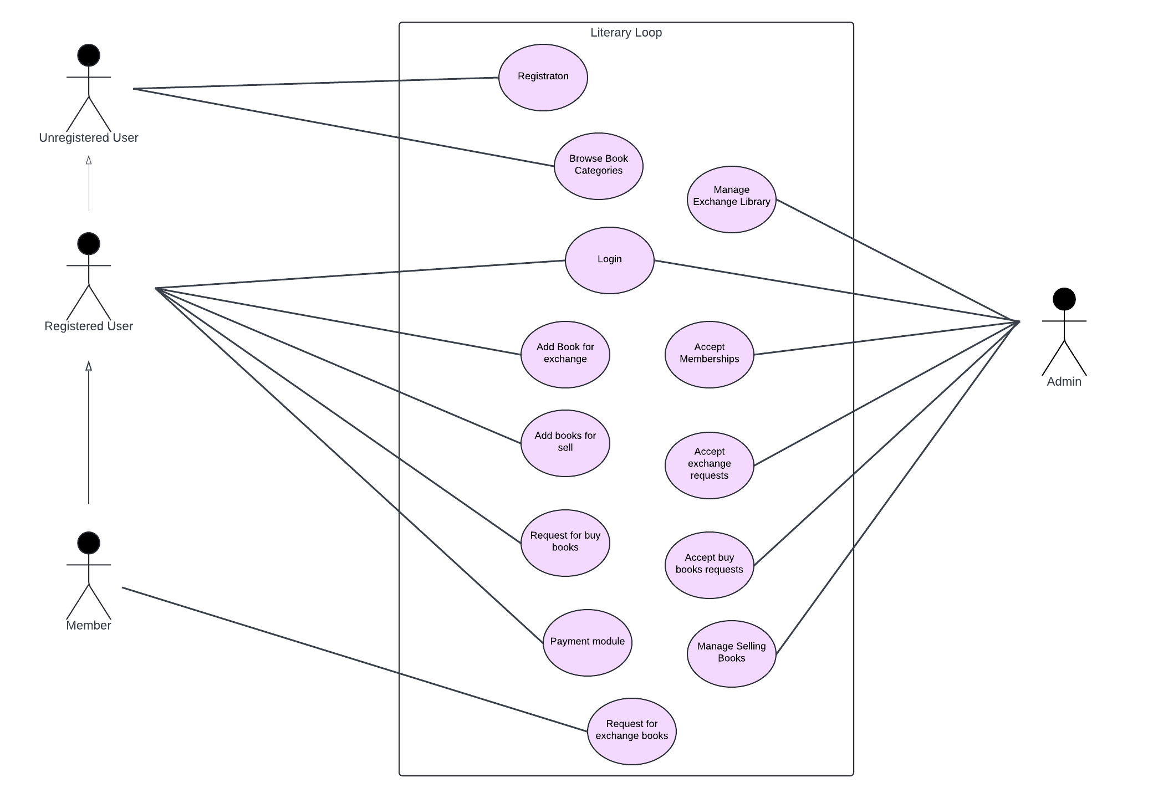

**Chapter 3**

# System Designing

# Selection of the process model

For the development of our Literary Loop website, the Waterfall model was chosen as the most suitable methodology. The Waterfall model is a structured and sequential approach to software development, consisting of distinct phases that are completed one after the other. These phases include requirements gathering, design, implementation, testing, and maintenance.

The Waterfall model is ideal for our project as it provides a clear and systematic framework for managing the development process. Each phase is well-defined and completed before proceeding to the next, ensuring that requirements are thoroughly understood and documented before design and development begin.

For our Literary Loop website, the Waterfall model offers several advantages. Firstly, it allows for a comprehensive understanding of project requirements, which is crucial for the successful development of a complex system like ours. By thoroughly gathering and documenting requirements upfront, we can minimize the risk of misunderstandings and scope creep later in the project.

Additionally, the Waterfall model provides a clear roadmap for the development process, making it easier to plan and manage project timelines. This is particularly important for our project, as we aim to deliver a reliable and user-friendly platform within a specified timeframe.

Furthermore, the Waterfall model is well-suited for projects where there is limited need for ongoing collaboration with end-users during development. In the case of our book exchanging and buying website, the requirements are relatively stable, and there is a clear understanding of what the end product should look like. This makes the Waterfall model an appropriate choice for our project, as it allows us to proceed through each phase of development in a logical and structured manner.

Overall, the Waterfall model is a suitable methodology for the development of our website due to its emphasis on thorough requirements gathering, clear project planning, and systematic approach to development. By following this model, we can ensure that our website meets the needs and expectations of our users while minimizing the risk of errors and delays.

# Tools used for Designing

* Use Case diagram - Lucid Chart
* Activity diagram - Draw.io
* Sequential diagram -Draw.io
* Class diagram – Draw.io

# A diagram of a computer Description automatically generatedActivity diagram for Exchanging a book.

# Sequence diagram

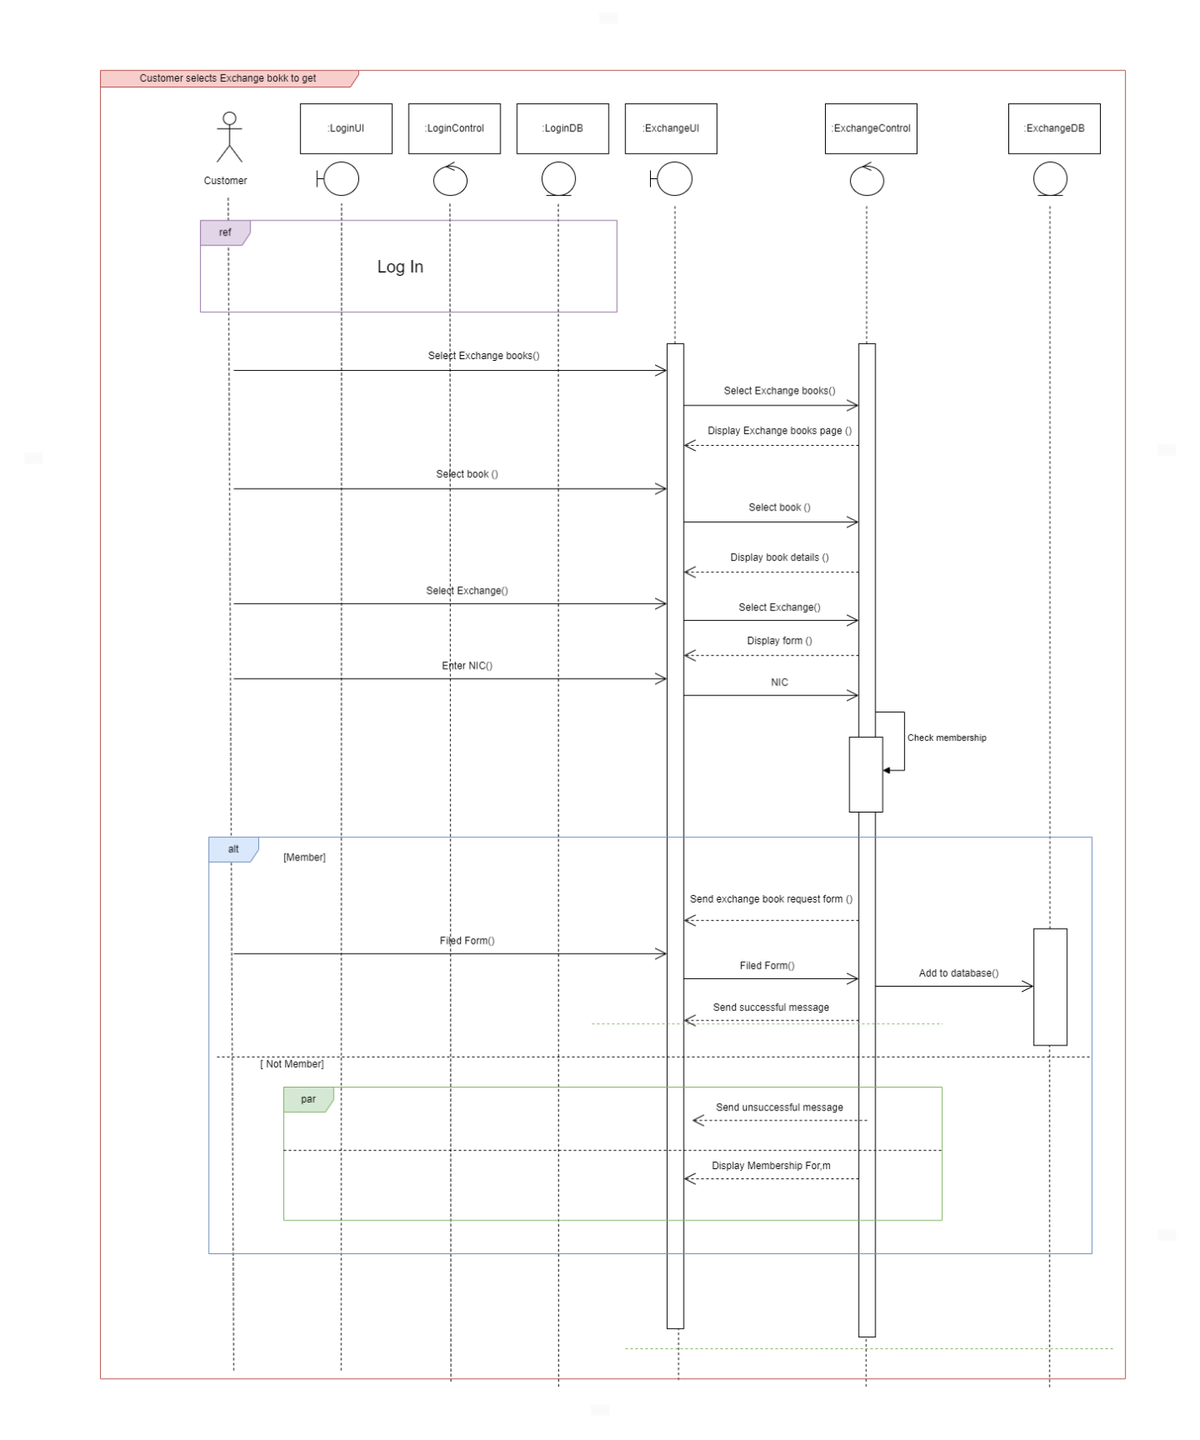

# Database design

# User Interface Design

**Chapter 4**

# System Development

# Hardware configuration

Literary Loop System was developed using 2 computers with the following hardware configurations.

Operating System : Windows 11 Home Single Language

System Type : 64-bit Operating System

Processor : Intel Core i5,i7

Installed Memory (RAM) : 16 GB,8GB RAM

Hard Disk Drive : 512GB

# Software configuration

**Programming stack**

* Html
* CSS
* Javascript
* Java
* MySQL

**Programming tools**

* Draw.io
* MySQL workbench
* Apache Tomcat version 9
* Visual Studio Code
* Eclipse IDE

# User Interface Development

**Home page for Unregistered user**

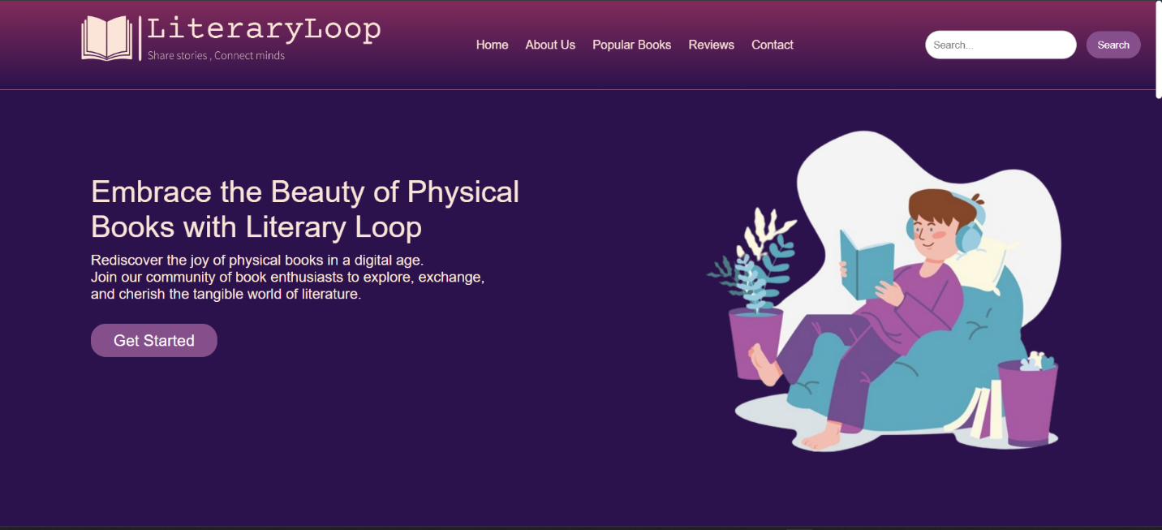

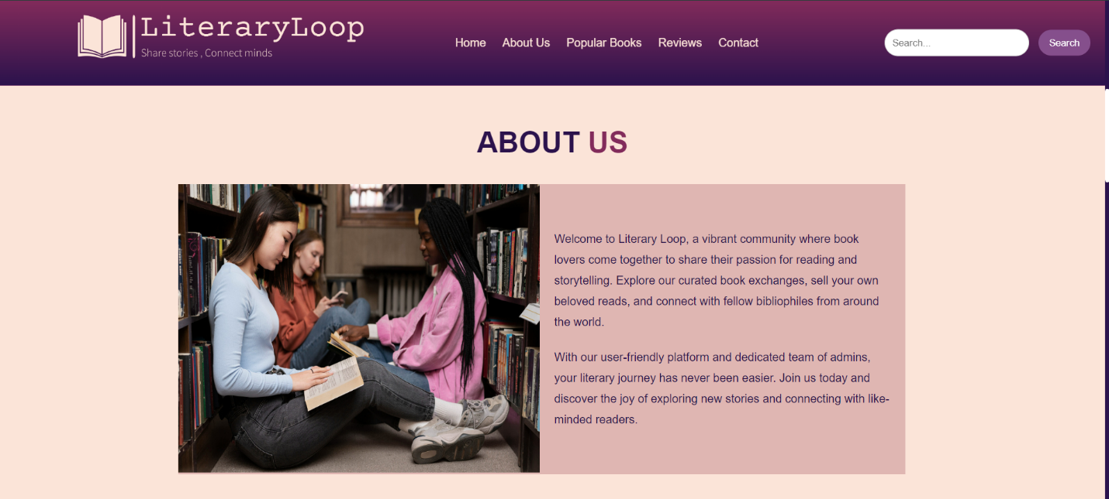

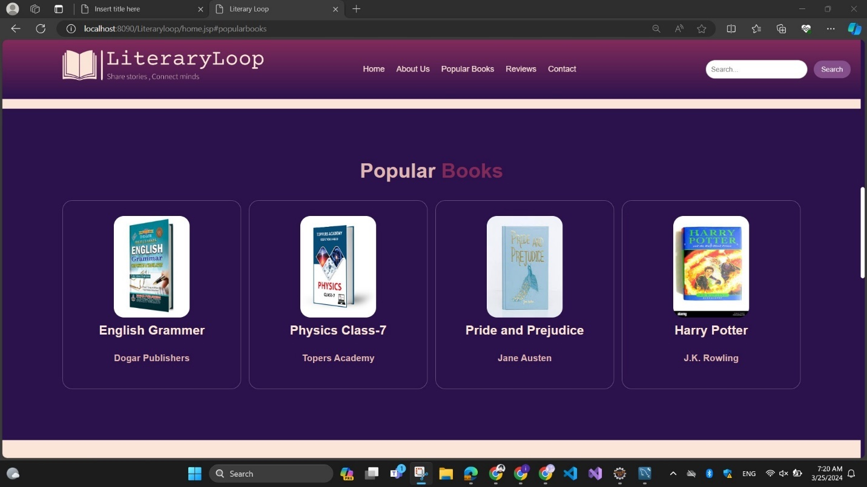

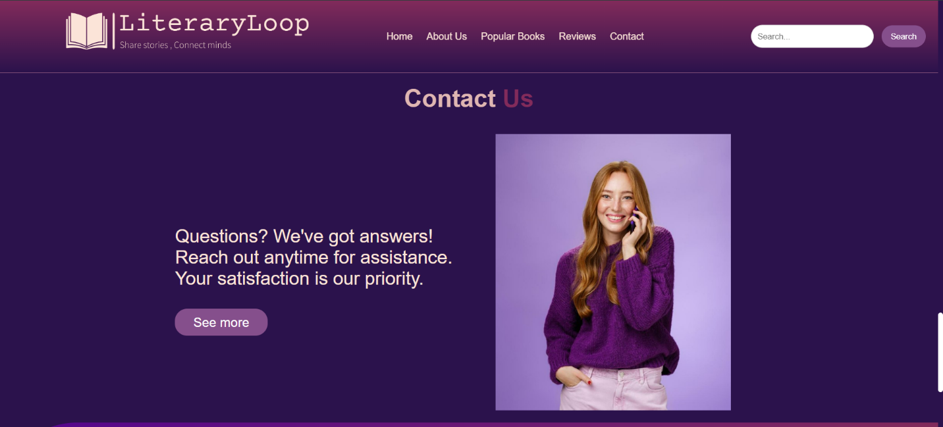

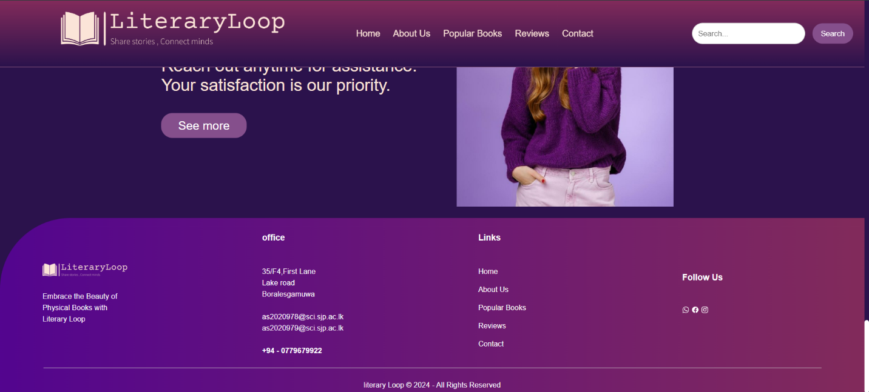

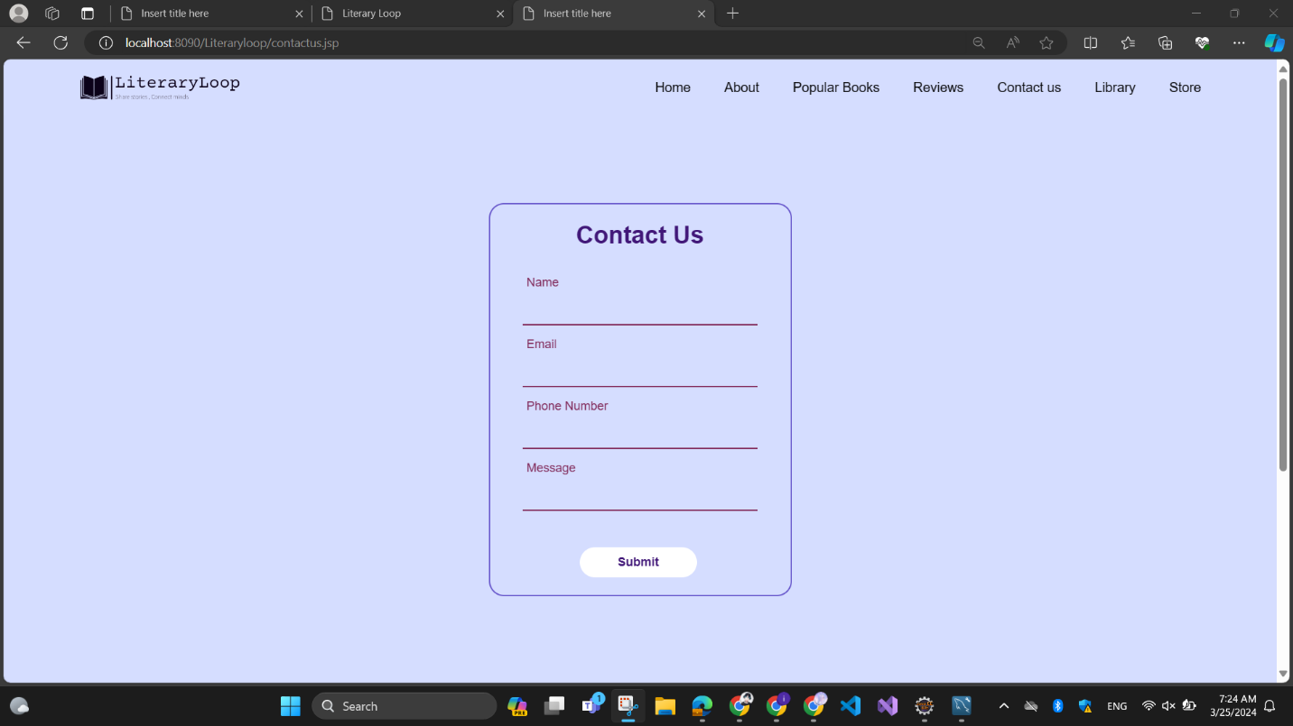

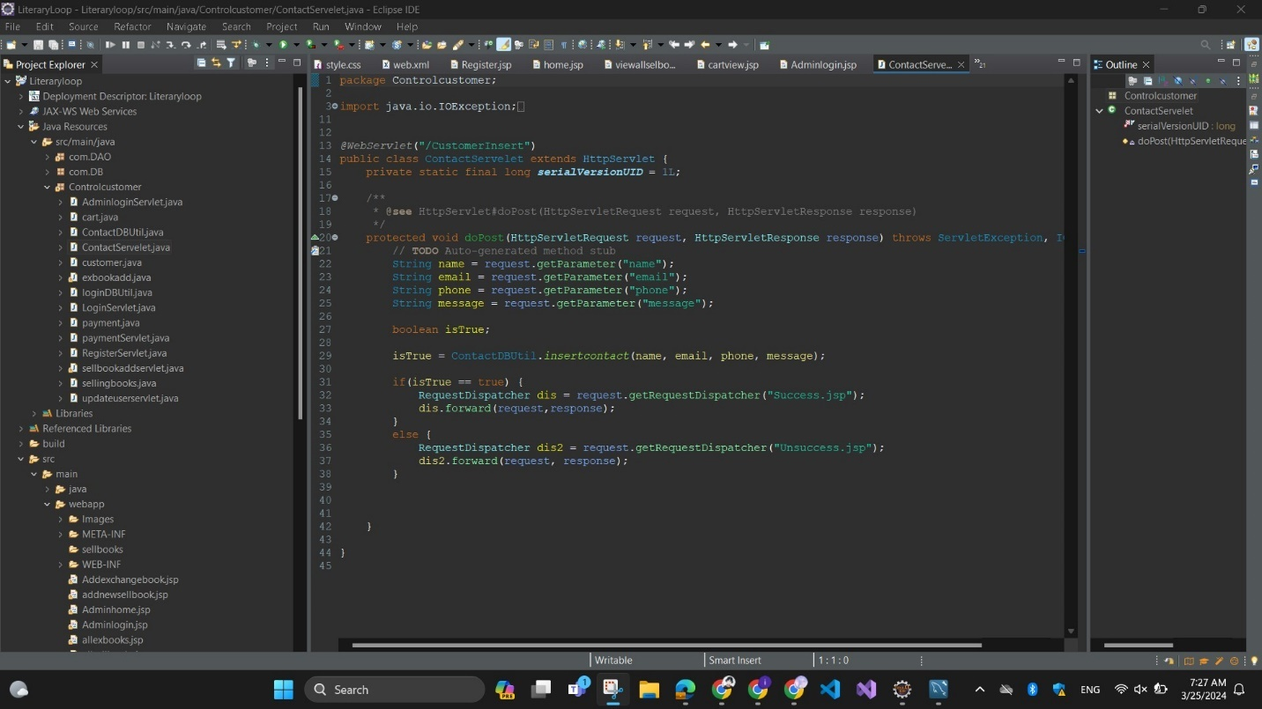

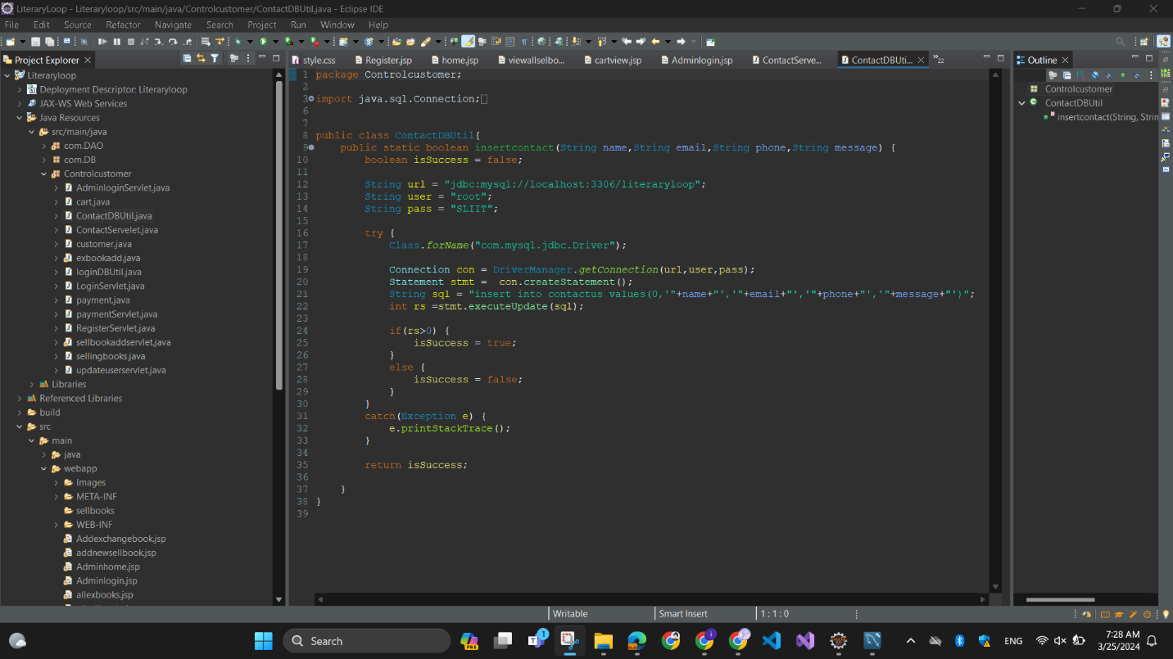

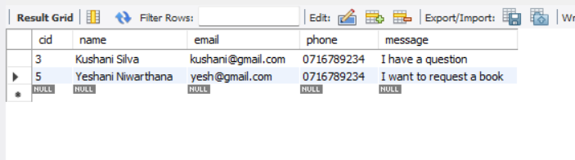

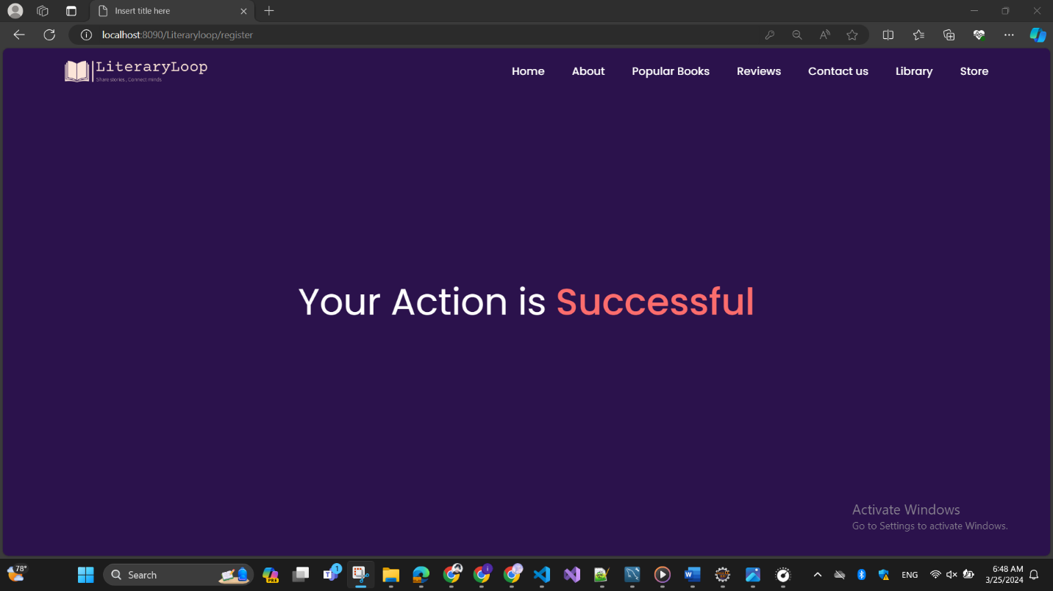

**Login page for registered user**

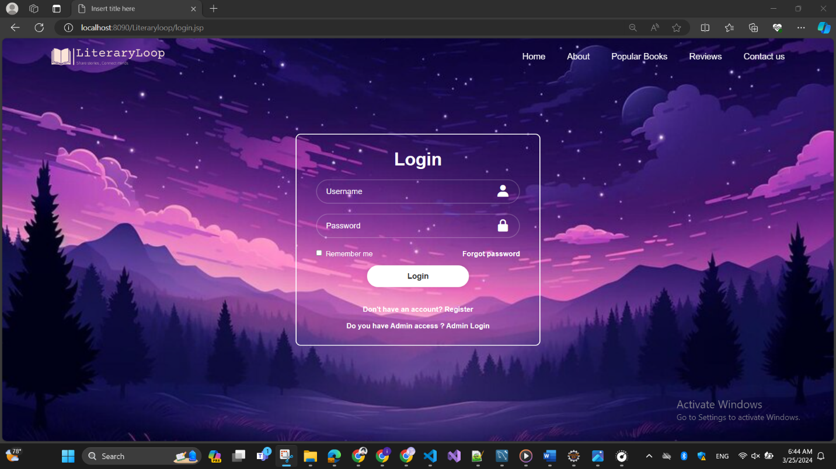

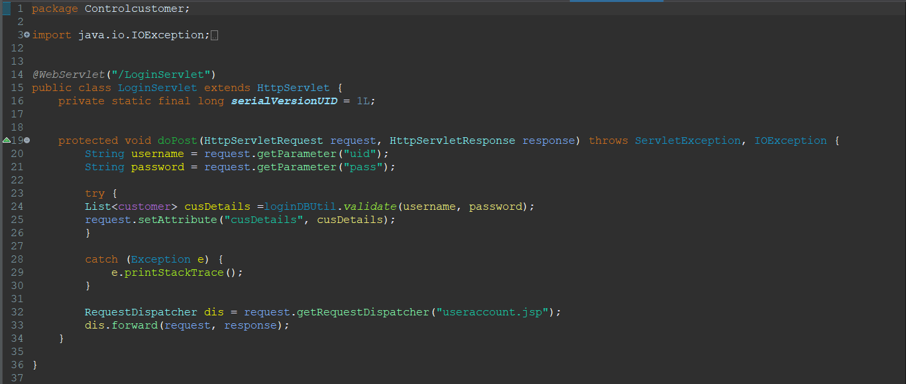

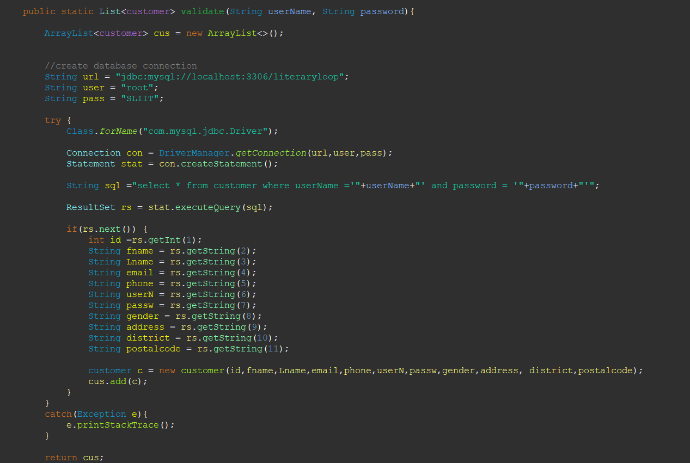

**Registration for unregistered user**

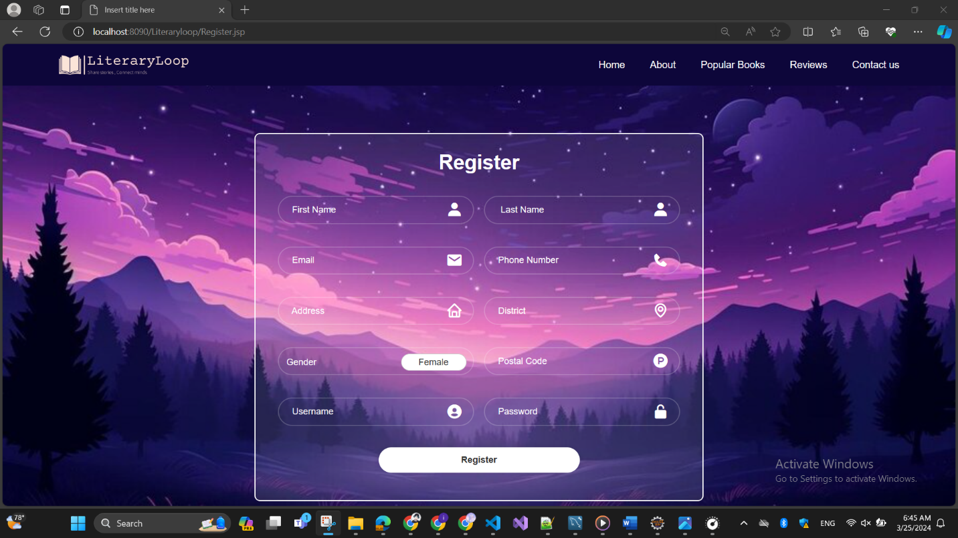

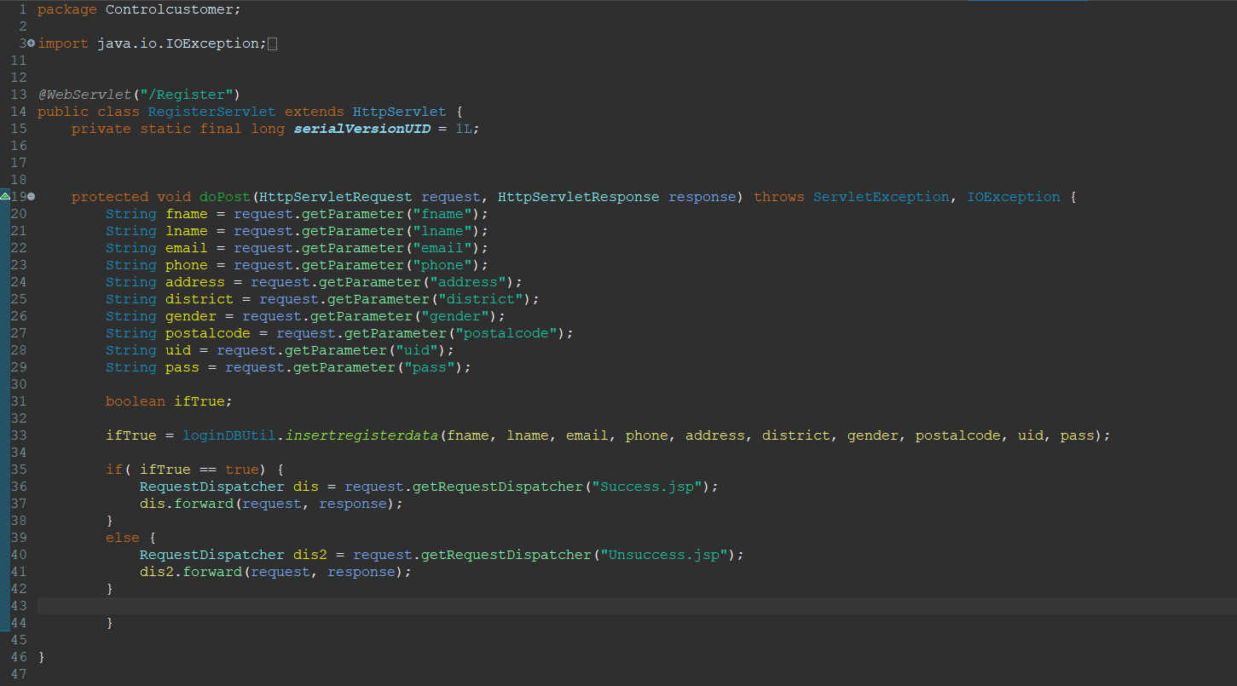

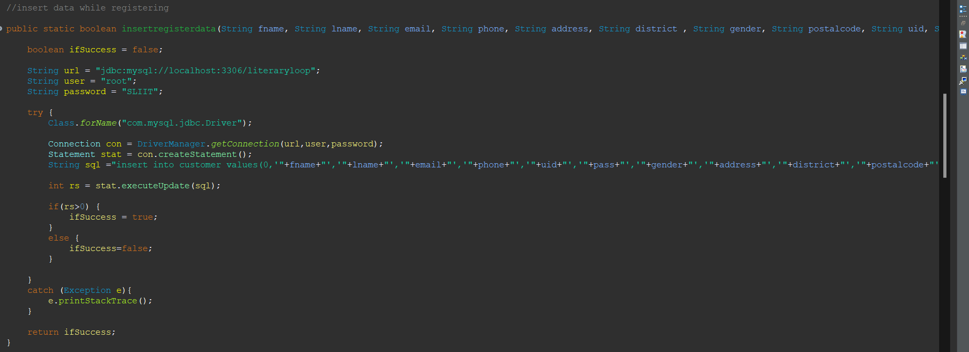

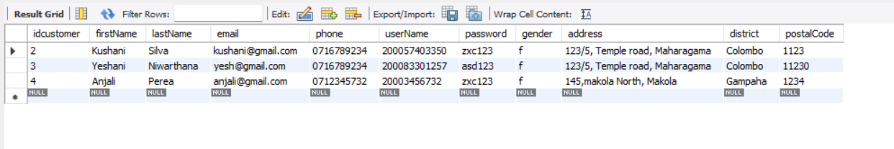

**Home page for registered user**

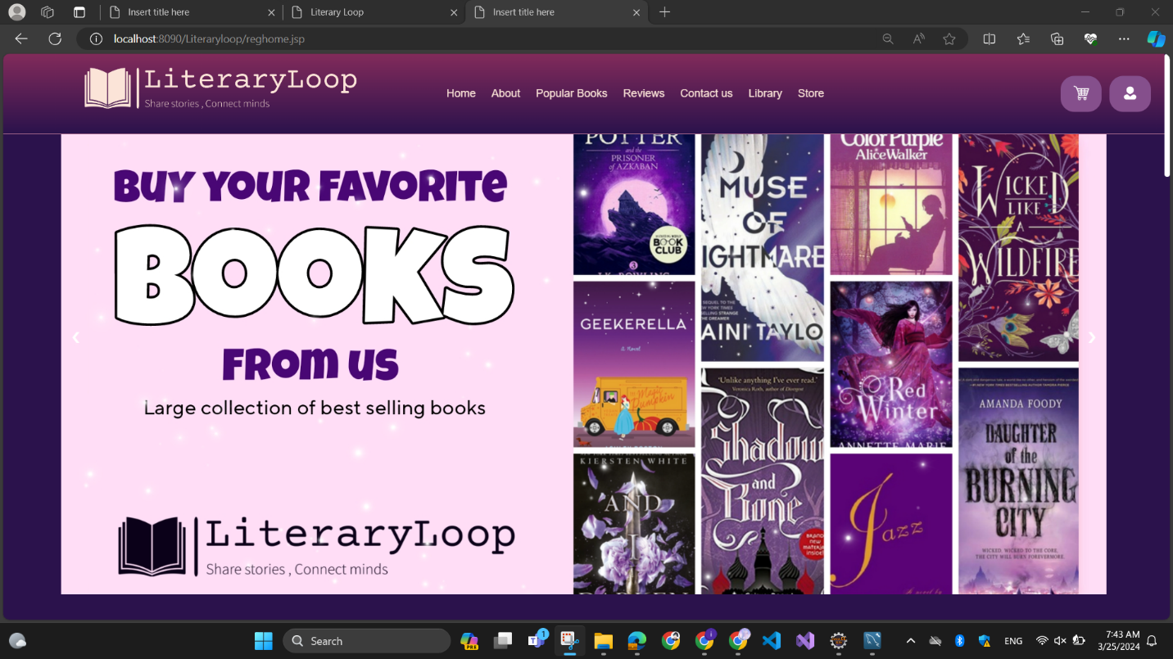

**Exchange book Library**

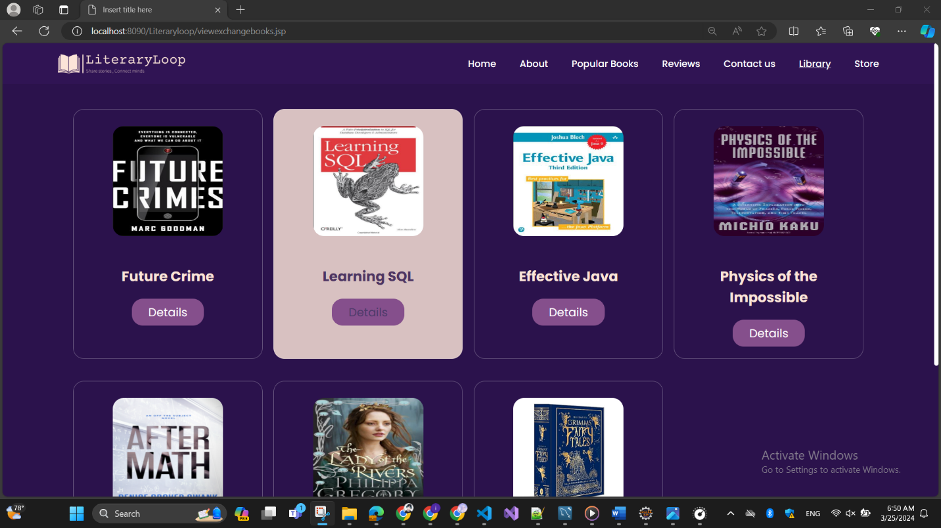

**Main Interface for book database handling**

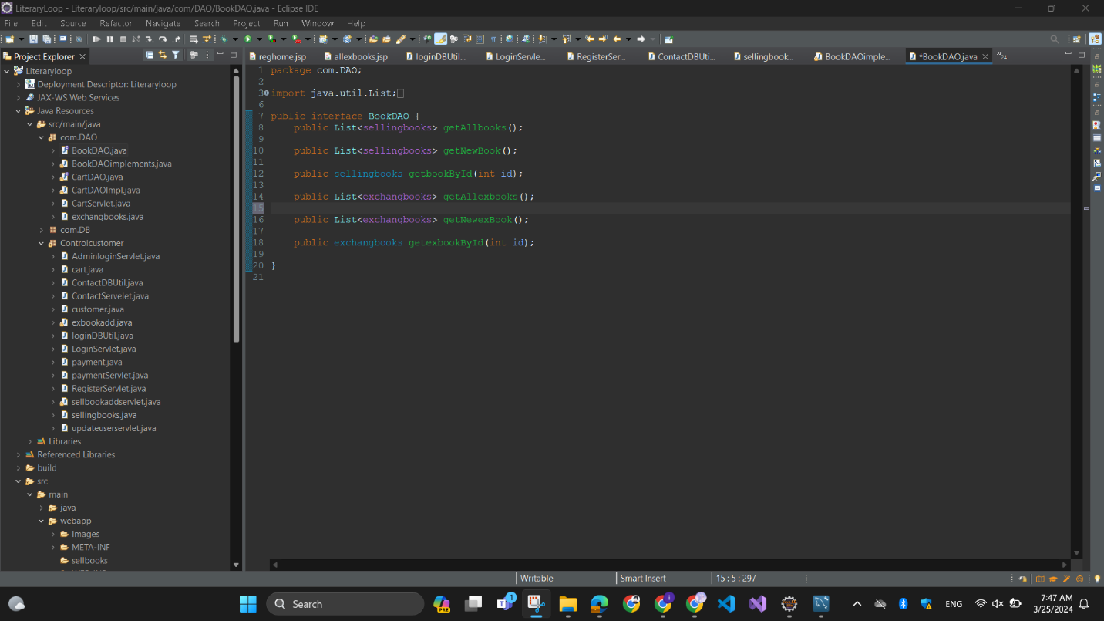

**Add new exchange book db Utile**

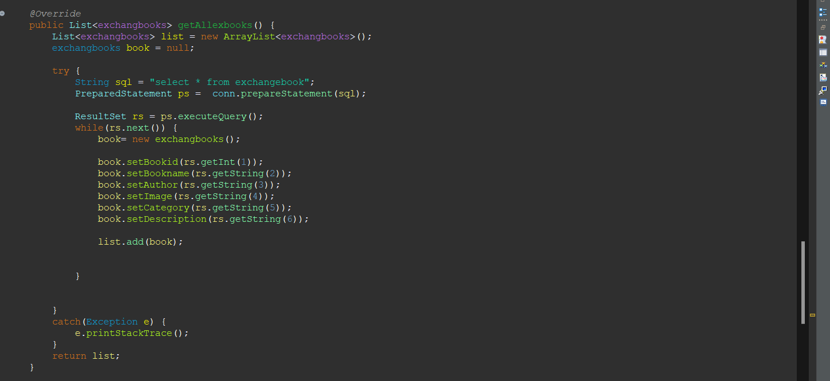

**Add new exchange book servelet**

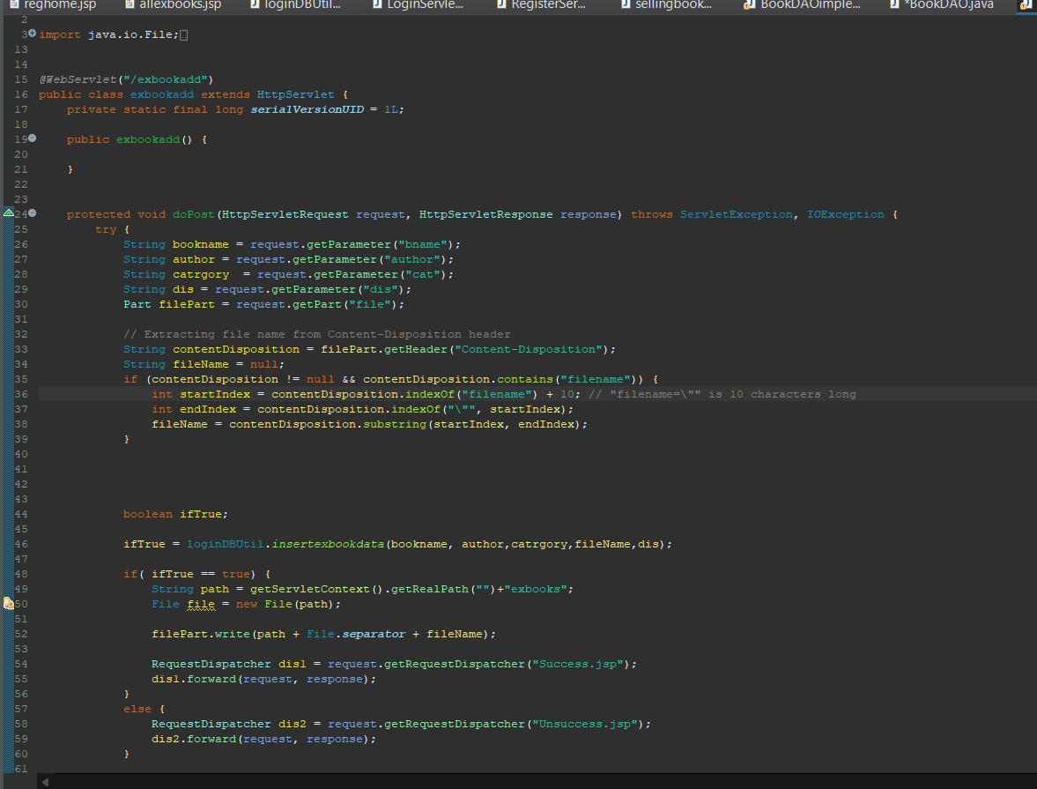

**Book details of exchange**

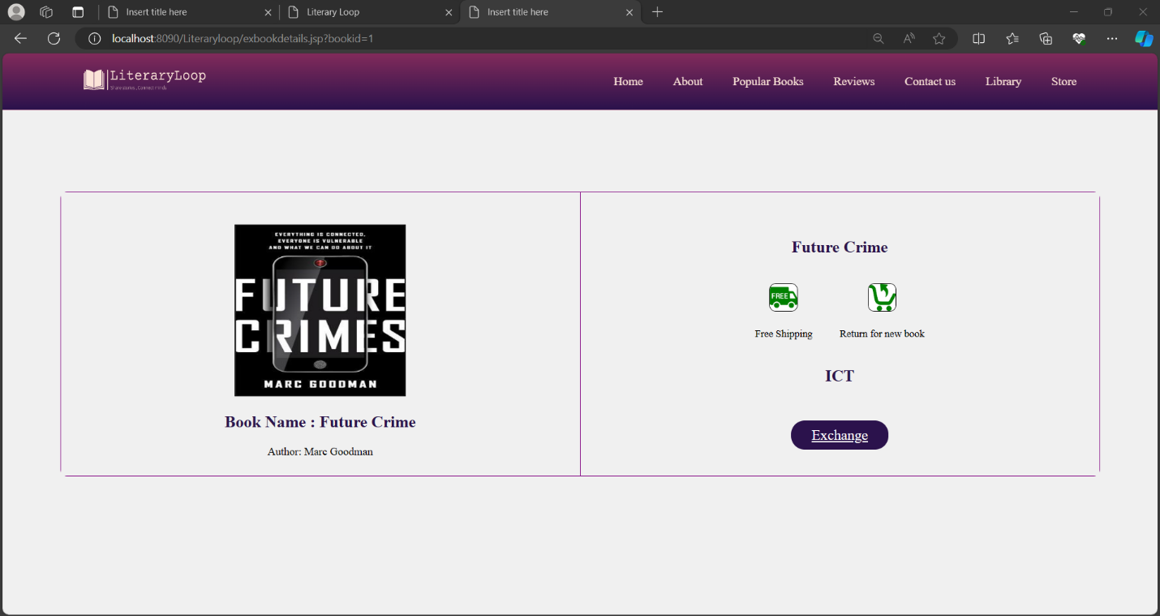

**View book details dbUtile**

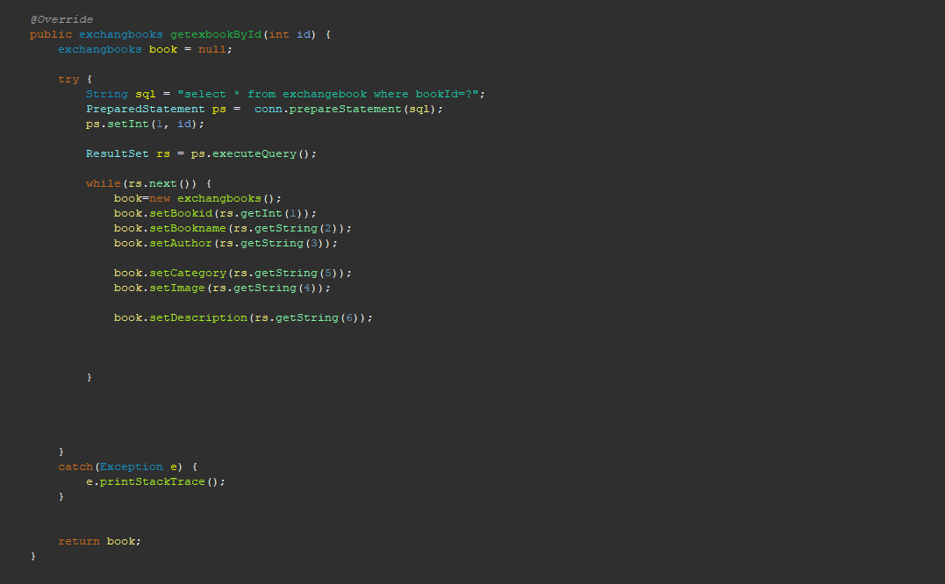

**Getting and displaying of exchange books with database connection**

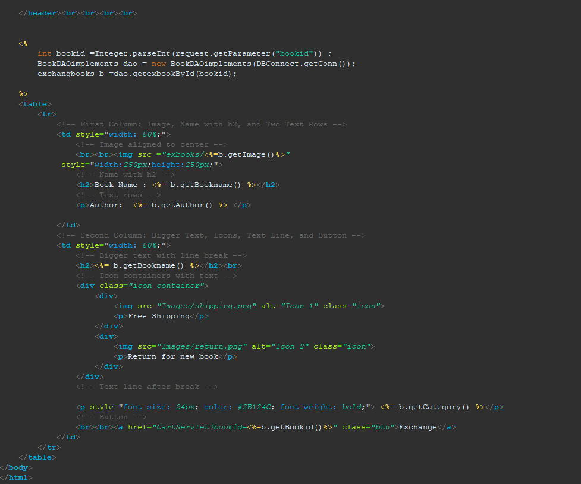

**Database table – Exchange book**

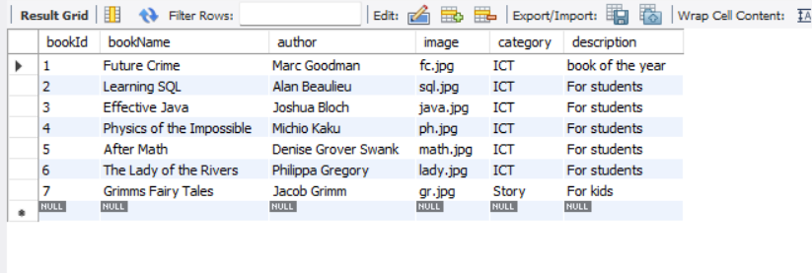

**view all books in store**

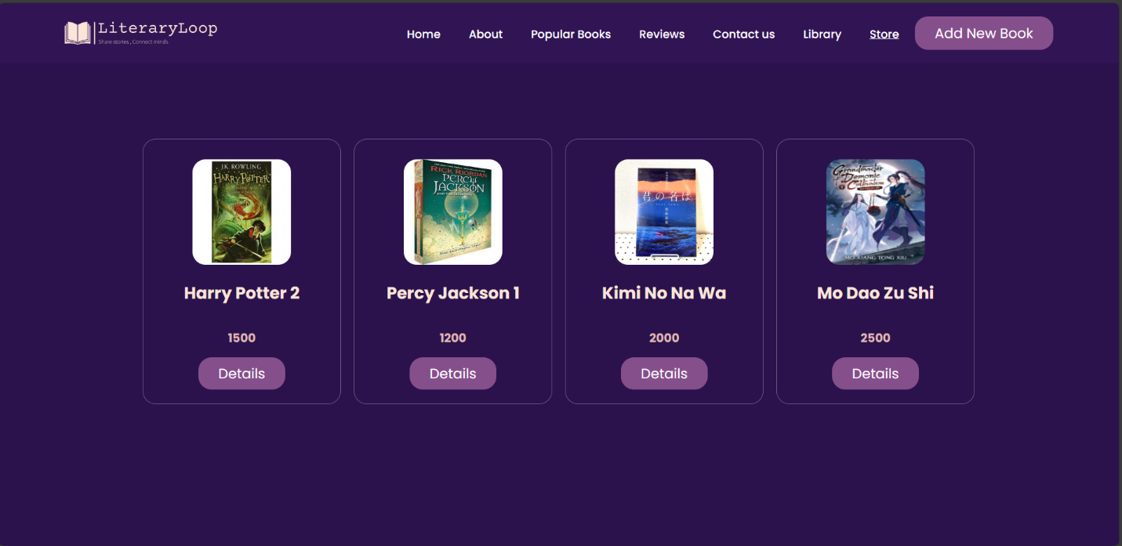

**Db Utile all books in store**

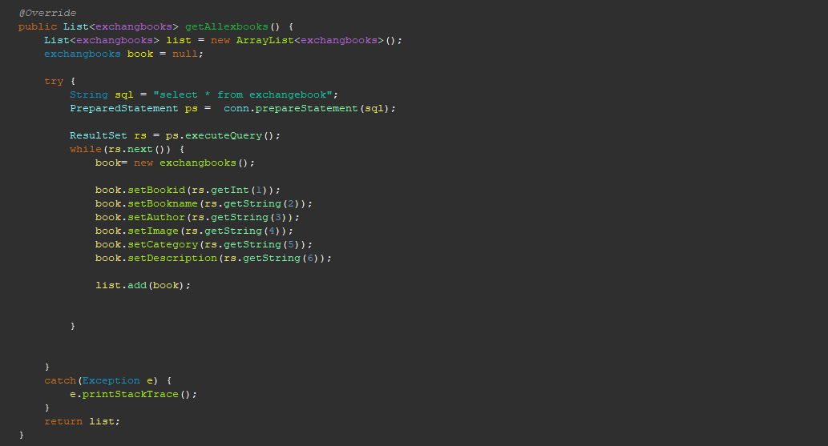

**Servlet in all books in store**

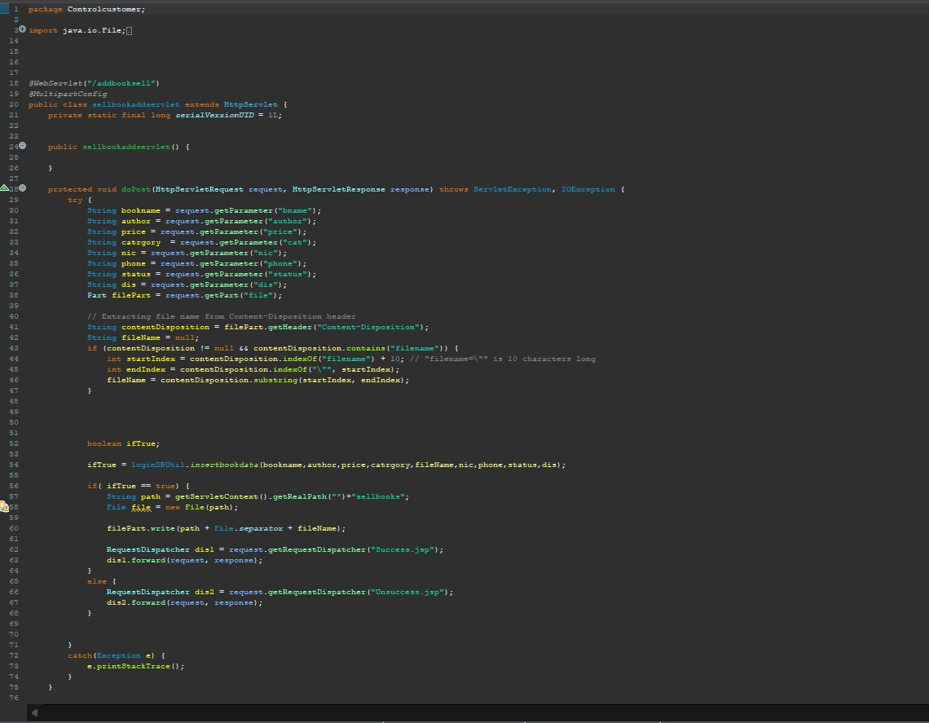

**Add new book to store**

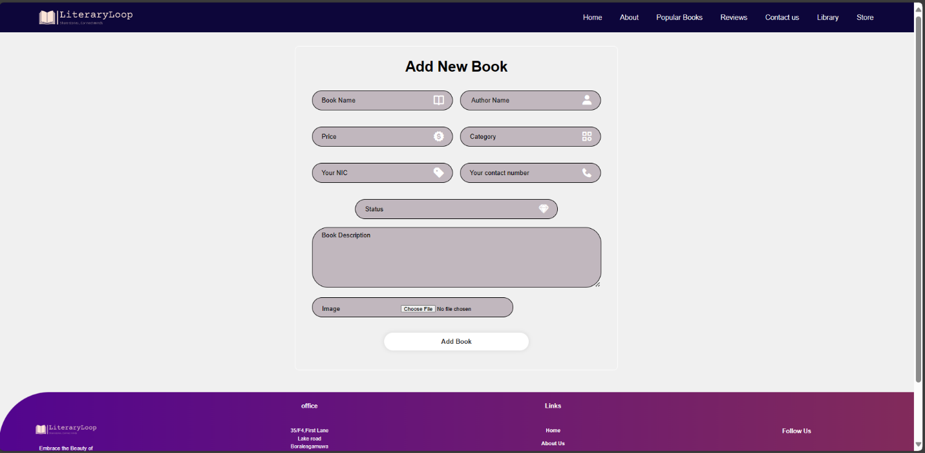

**Db Utile**

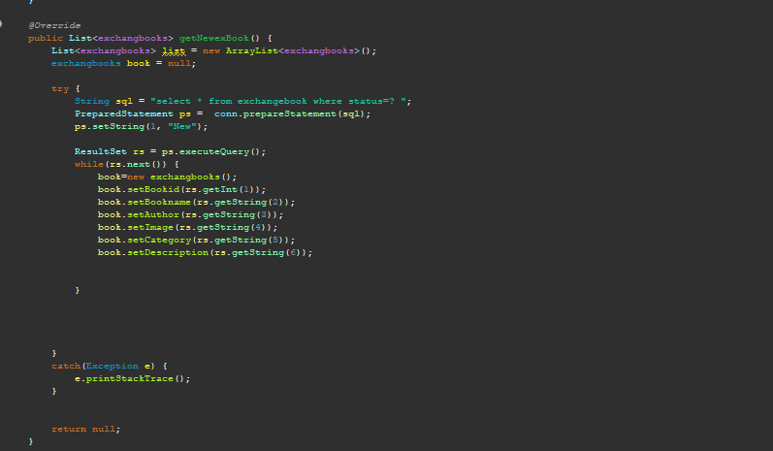

**Database retrieve and store by front end**

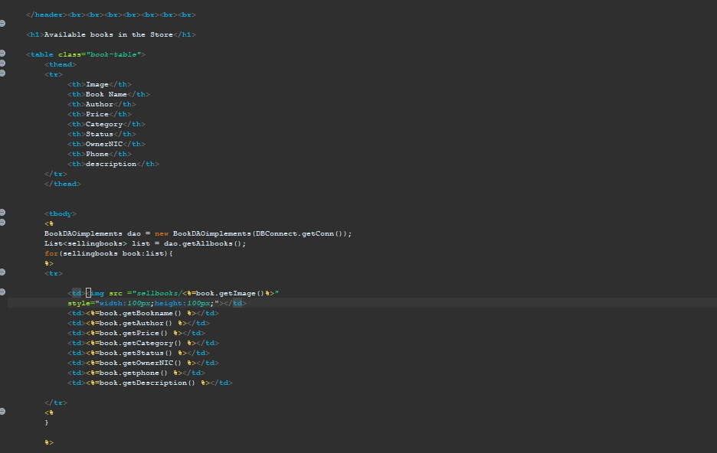

**View book details of selling book**

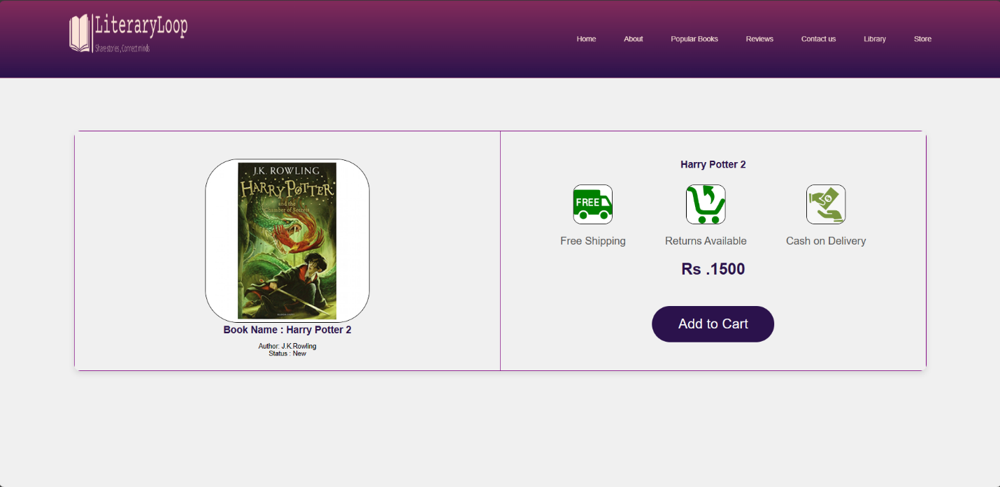

**The way of retrieving data of a book**

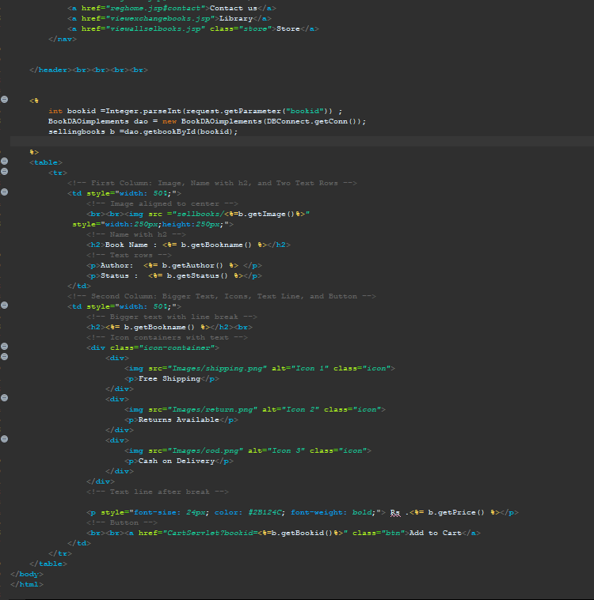

**dbUtile of book details retrieving**

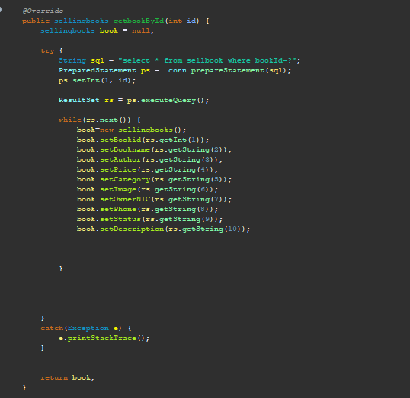

**Sellbook Database**

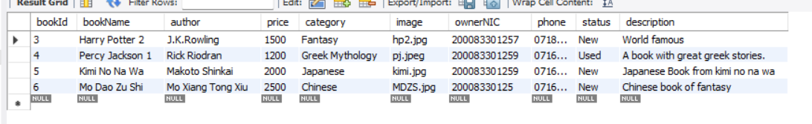

**Add to cart function**



**Add to cart Servlet**

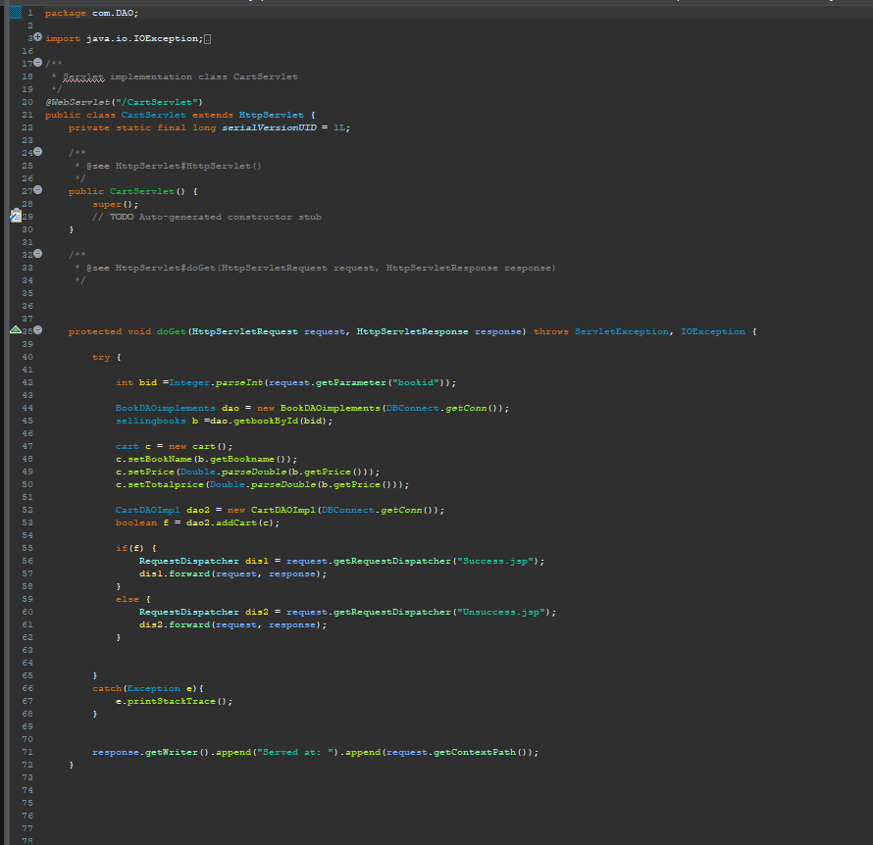

**Cart DBUtil Database handling**

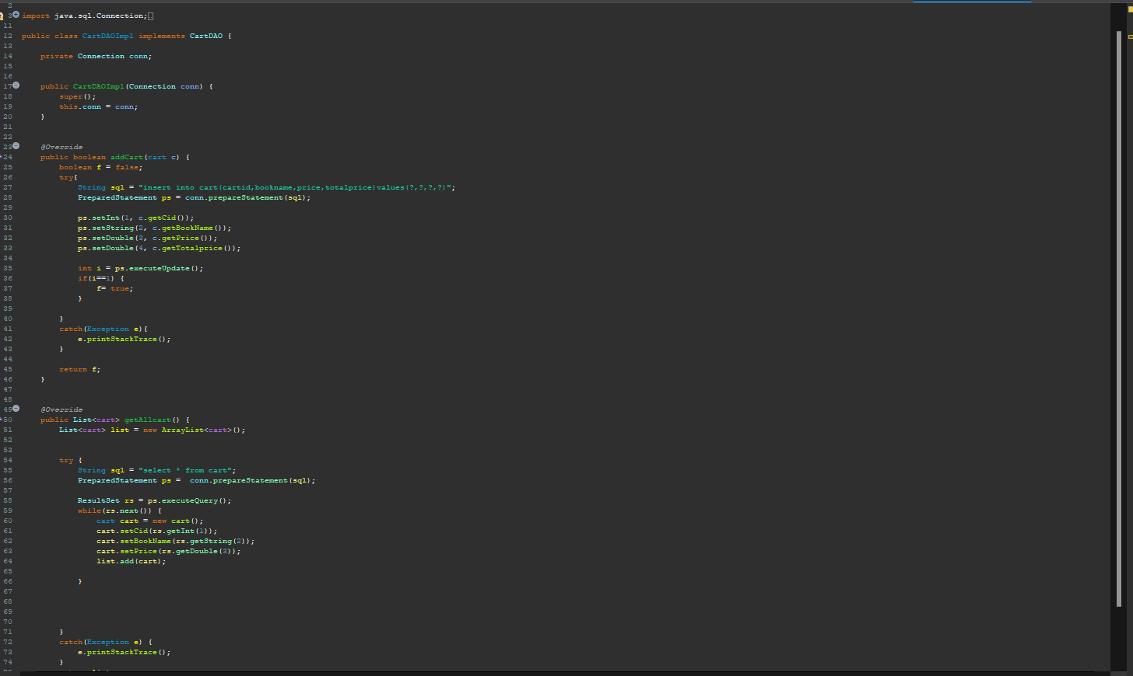

**Cart database**

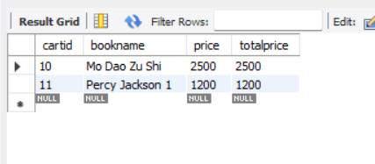

**Payment Portal**

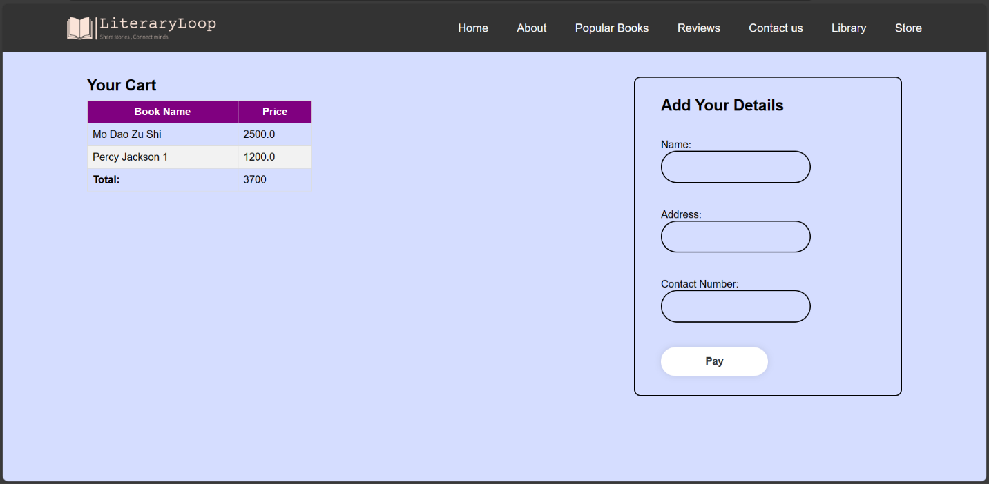

**Payment Backends**

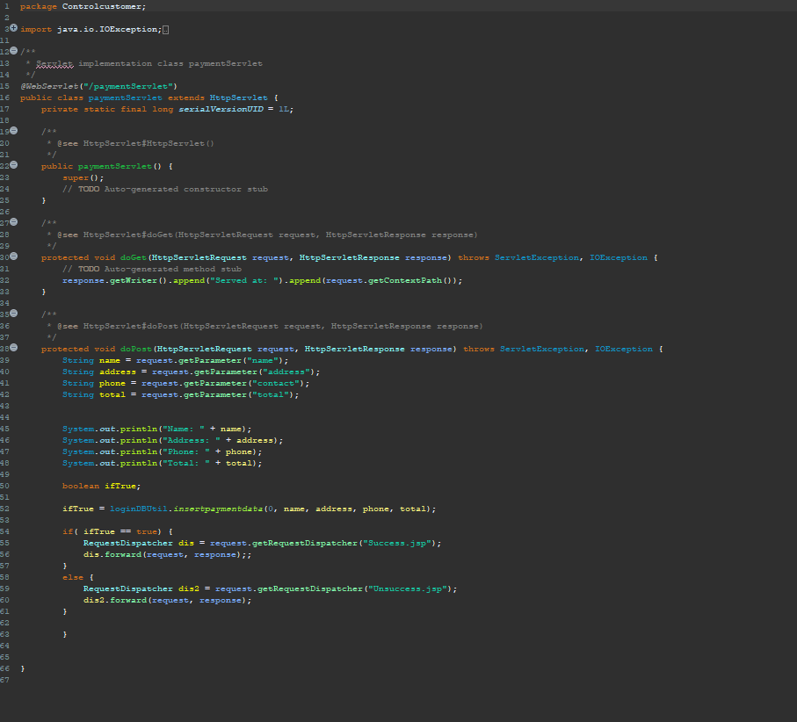

**Chapter 5**

# System implementation & Maintenance

This chapter provides an overview of the implementation and maintenance phase for our book buying and exchange system. During this stage, the developed software is transitioned into practical operation within the book exchange domain. Implementation involves careful planning, evaluating existing system constraints, designing changeover methods, and installing necessary hardware and software. These activities are crucial for ensuring the system's readiness before going live. Maintenance plays a vital role in ongoing upkeep and enhancement to meet evolving needs. Through meticulous planning and execution, we aim to establish a reliable platform for seamless book exchanges and purchases, fostering a vibrant literary community.

**Chapter 6**

# System Testing & Evolution

System Testing serves as a pivotal phase in the development of software, aimed at meticulously evaluating the behavior of a fully integrated product in alignment with the Software Requirements Specification (SRS) document. In the context of our book buying and exchanging system, this testing phase is crucial to ensure that the system impeccably aligns with the outlined functional, and end-user requirements delineated in the SRS document.

The primary objective of System Testing revolves around validating and verifying that our software product seamlessly meets the user's specifications and objectives, as envisioned during its design and development phases. It is imperative to ascertain that the system functions as anticipated and can be implemented with utmost reliability. Moreover, System Testing serves as a robust mechanism to uncover potential errors, as software intricacies may manifest in unforeseen ways, necessitating thorough examination.

**Black box testing**

Black box testing treats the coded module as an opaque entity, focusing solely on its external behavior. Inputs designed to provoke errors are fed into the system, and the resulting outputs are analyzed for anomalies. While it may not detect all errors, black box testing mainly assesses functional requirements. In our book buying and exchanging system, this method validates the system against predefined specifications to ensure it behaves as expected. Through this approach, we aim to identify and rectify any discrepancies, enhancing the system's reliability for users.

**White box testing**

White box testing is an approach that leverages the internal structure of procedural design to derive test cases. By employing white box testing techniques, we generate test cases that cover all logical decisions, test loops at their boundaries, and validate internal data structures. In our book buying and exchanging system, white box testing is utilized to validate the internal logic and structure of the software, ensuring it operates as intended and meets specified requirements.

# Discussion

The book buying and exchanging system presented in this project offers a comprehensive solution to address the needs and challenges faced by book enthusiasts in accessing, purchasing, and exchanging books. Through a thorough analysis of the functional requirements and the shortcomings of existing systems, our system aims to provide an intuitive, secure, and user-friendly platform for book transactions.

One of the key aspects of our system is its robust user authentication and authorization mechanisms. By implementing secure access controls for different user types, including administrators, registered users, and unregistered users, our system ensures the protection of user data and privacy. This not only enhances the overall security of the platform but also provides a personalized experience for users based on their roles and privileges.

Furthermore, our system streamlines the membership approval process, allowing administrators to efficiently review and approve membership requests. This automated process accelerates user onboarding and fosters a dynamic and engaged book exchange community. Additionally, administrators benefit from dedicated tools for book management, facilitating the seamless organization and updating of book listings, thereby improving the overall user experience.

Integration is another key strength of our system, as it seamlessly integrates book selling, buying, and exchange functionalities. This cohesive approach enhances user convenience and satisfaction by providing a unified platform for all book-related transactions. Moreover, the integration of a secure payment system ensures smooth and reliable transactions, instilling confidence in users and promoting trust in the platform.

In terms of user support, our system prioritizes user satisfaction by offering accessible channels for assistance and inquiries. The inclusion of features such as the "Contact Us" functionality enables users to seek help or clarification easily, enhancing their overall experience on the platform.

Overall, our book buying and exchanging system represents a significant advancement in the realm of online book transactions. By addressing the limitations of existing systems and leveraging innovative functionalities, our system offers a compelling solution that caters to the diverse needs of book enthusiasts while promoting a thriving and dynamic book exchange community.

# Future Enhancements

**Mobile Application Development**

Develop a mobile application for the book buying and exchanging system to provide users with access to the platform on their smartphones and tablets. A mobile app would offer convenience and flexibility, allowing users to browse, buy, and exchange books on the go.

**Virtual Book Clubs**

Implement virtual book clubs or reading groups within the platform where users with similar interests can connect, discuss books, and organize group exchanges or purchases. This feature can promote community engagement and foster meaningful interactions among members.

# Group Members

|  |  |  |  |  |
| --- | --- | --- | --- | --- |
|  | Name with Initials | Registration number | Contact Phone number | Email |
| 1 | L.K.I.Silva | AS2020978 | 0779679922 | as2020978@sci.sjo.ac.lk |
| 2 | K.D.Y. Niwarthana | AS2020979 | 0718789167 | As2020979@sci.sjp.ac.lk |